PRESS KIT – JOANA PASTRO

This press kit contains:

- Short and Long Author Biography
- Book Info
- High- and low-resolution headshots
- Contact Info
If you have any questions, please contact me at joe.pastro@gmail.com.
Professional headshots by Stacy Toeniskoetter https://www.justtoseeyousmile.com/
“Desk” headshot by Leo Pastro.

Short Author Biography:

Joana Pastro always wanted to be an artist of some sort. So, she became an architect. But once her first child was born, all the visits to the library, and the countless story times made Joana start dreaming of becoming a children’s book author. After a lot of reading, writing and revising, her dream is coming true. Her debut picture book, LILLYBELLE, A DAMSEL NOT IN DISTRESS, illustrated by Jhon Ortiz, will be published by BM&K in Fall/2020. Her second book, BISA’S CARNAVAL, illustrated by Carolina Coroa will be published by Scholastic in Spring/2021. Originally from Brazil, Joana now lives in Florida with her husband, her three extremely creative children and a rambunctious Morkie. You can find her on Twitter @jopastro, Instagram @jppastro , or her website at www.joanapastro.com.

Long Author Biography:

For as long as Joana can remember, she wanted to be an artist of some kind. So, she became an architect. But once her first child was born, all the visits to the library, and the countless story times made Joana start dreaming of becoming a children’s book author. She had no idea how to start, so for seven years all she did was collect story ideas on a little notebook. Finally, one Sunday afternoon she decided to sit down and write… Soon Joana discovered that writing children’s books isn’t easy. But she didn’t give up. She became a member of SCBWI (Society of Children's Book Writers and Illustrators), joined a critique group, made many writing friends, took classes, workshops, went to conferences, and did a lot of reading, writing and revising. One day, she sent out a story to an agent named Natascha Morris. The agent loved it and decided she wanted to help Joana share her stories with the world. And now here is Joana, still chasing her dream. But every day she gets a step closer to making it come true. Her debut picture book, LILLYBELLE, A DAMSEL NOT IN DISTRESS, illustrated by Jhon Ortiz, will be published by Kane Press in Fall/2020. Her second book, BISA’S CARNAVAL, illustrated by Carolina Coroa will be published by Scholastic in Spring/2021.
Originally from Brazil, Joana now lives in Florida with her amazing husband, her three extremely creative children and a rambunctious Morkie.

You can find her on Twitter @jopastro, Instagram @jppastro , or her website at www.joanapastro.com.

Book Info:

LILLYBELLE, A DAMSEL NOT IN DISTRESS
By Joana Pastro
Illustrated by Jhon Ortiz
Boyds Mill & Kane
Release Date: Fall 2020

When faced with the danger of giants, ogres, and witches, other damsels might quake with fear . . . but not LillyBelle!
At the School for Damsels, LillyBelle enjoys many damsel-in-training classes, like cake baking and vocal training, but the rule that a damsel must be in distress . . . not so much. When she's captured by one villain after another, LillyBelle will need to use her charm and her wit to save herself and prove once and for all that damsels don't have to be in distress--all in time for tea!

BISA’S CARNAVAL
By Joana Pastro
Illustrated by Carolina Coroa
Scholastic
Release Date: Spring 2021.

“Trumpets, trombones, tubas and saxophones sing louder, faster, faster, louder!
It’s CARNAVAL!”

With help from her bisa (great-grandma), a young girl in Brazil prepares for Carnaval: bright costumes, feathers, flowers, and plenty of glitter. But bisa must stay home. As the girl hugs bisa goodbye, the music pulls her in. Excitement is everywhere, on every sight, sound and scent. But…

Carnaval isn’t the same without bisa.

With the blow of a whistle and lots of love, the girl will make sure BISA’S CARNAVAL is the best one ever!

Headshots:
High-resolution headshots:
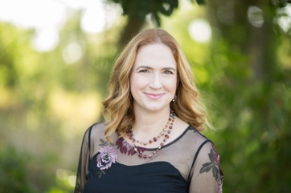
Just to see you smile

Low-resolution headshots:
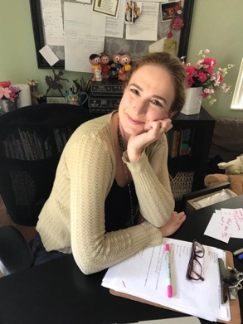
Leo Pastro

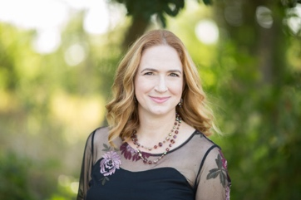
Just to see you smile

Contact Info:
Email: joe.pastro@gmail.com
Website: www.joanapastro.com
Twitter: https://twitter.com/jopastro
Instagram: https://www.instagram.com/joanapastro/

